2-1: Determine the moments at each end of the beam by using both methods of Stiffness-Factor modified and unmodified. Assume the supports at B and C are rollers and A and D are pins. EI is constant.

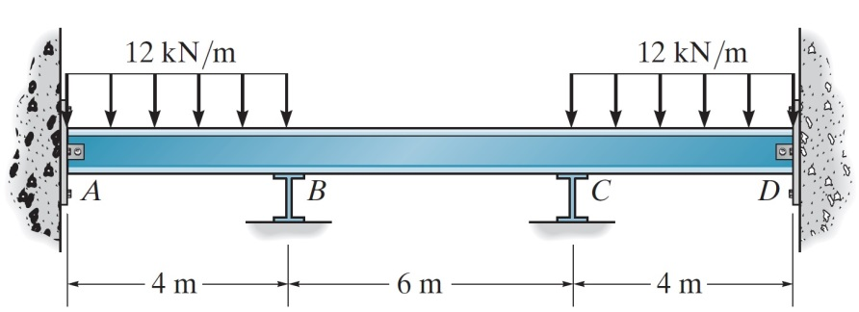

2-2: Determine the moment at each end of the beam, and then draw the moment diagram for the beam. Assume the support at A is pinned, B is a roller and C is fixed. EI is constant.

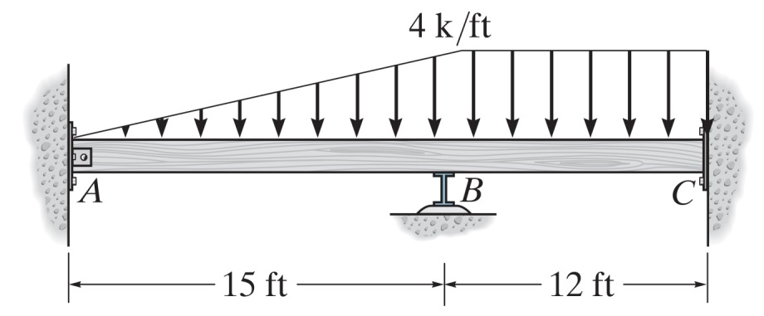

2-3: Determine the moments at each end of the frame. Assume the support at B is pinned, C is a roller and A is fixed. EI is constant.

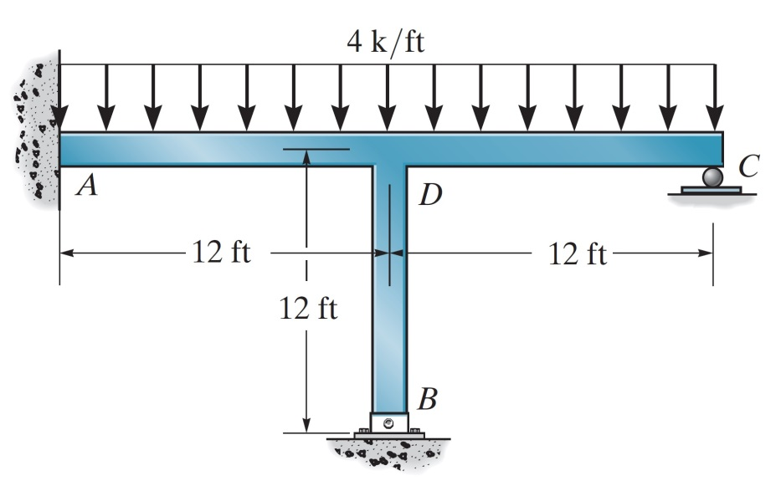
2-4: Determine the moments at each end of the frame. Assume the supports at A and B are pins. EI is constant.

